**Quiz for Java Programming** (Tutor: cyd@bupt.edu.cn)

Unit04-GUI Programming – Event driven programming

1. An event can be defined as a type of signalto the program that something has happened. The event is generated by. An event source .
2. [T/F] . An inner class can not reference outer class's data and methods.F
3. A java inner class can be accessed using the outer class name.
4. [T/F] An anonymous inner class must always extend a superclass or implement an interface and can have an explicit extends or implements clause.T
5. a Single Abstract Method (SAM) interface is actually a lambda function
6. Write a program that uses two buttons to control the size of the China National Flag. First, the listener class as a package class, then change it to an inner class.

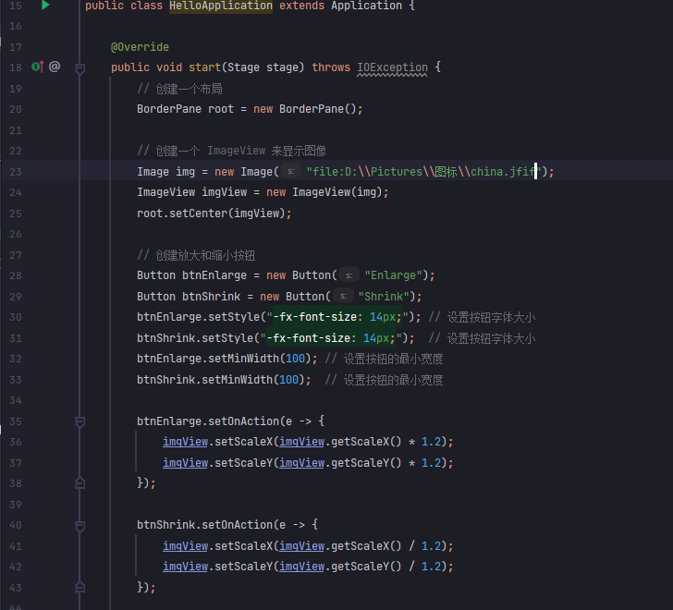

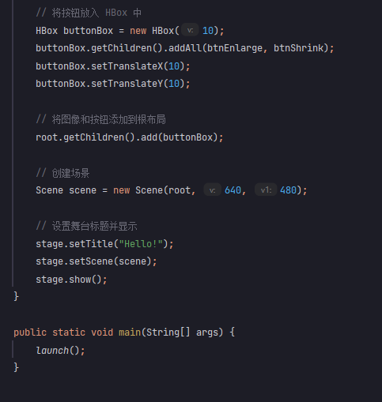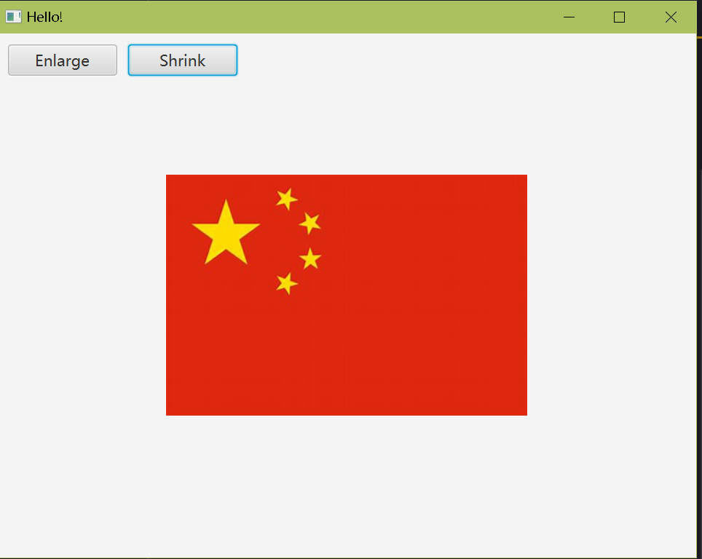

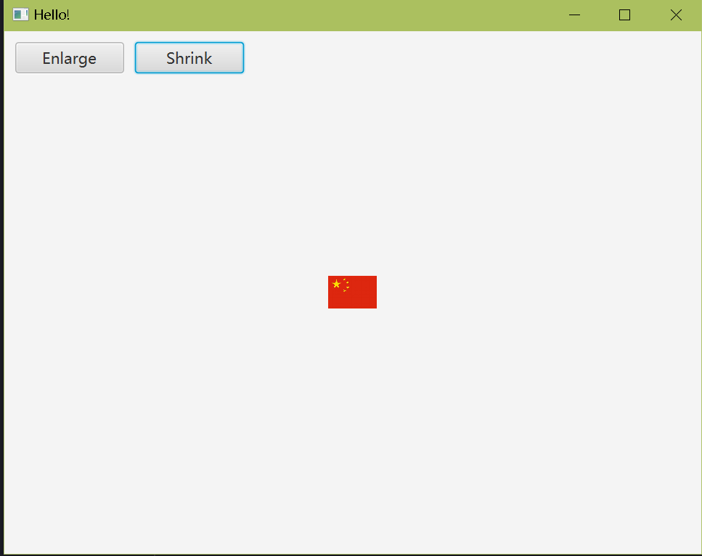

1. Based on quiz6, change the inner listener class to an anonymous inner class(A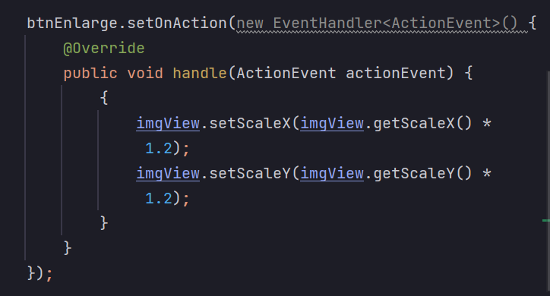IC).
2. Based on quiz7, change the AIC to a lambda expression.

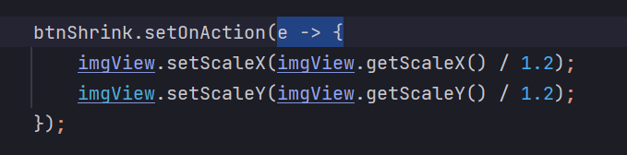

1. Based on quiz8, use mouse to move the rectangle.

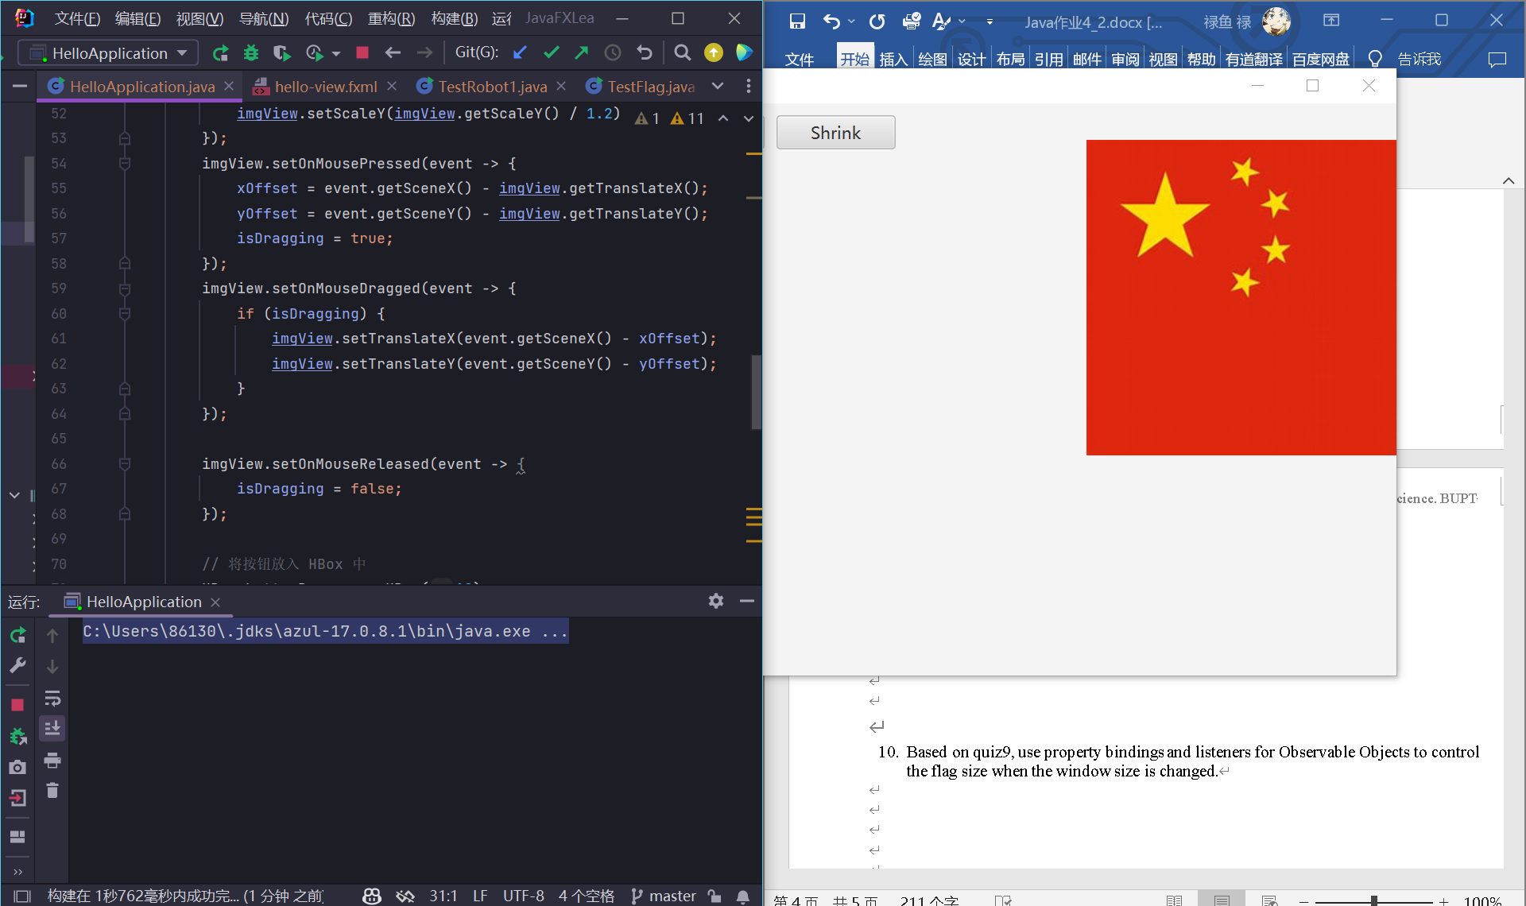

1. Based on quiz9, use property bindings and listeners for Observable Objects to control the flag size when the window size is changed.

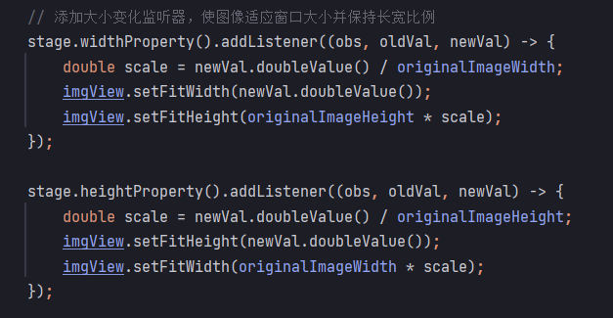

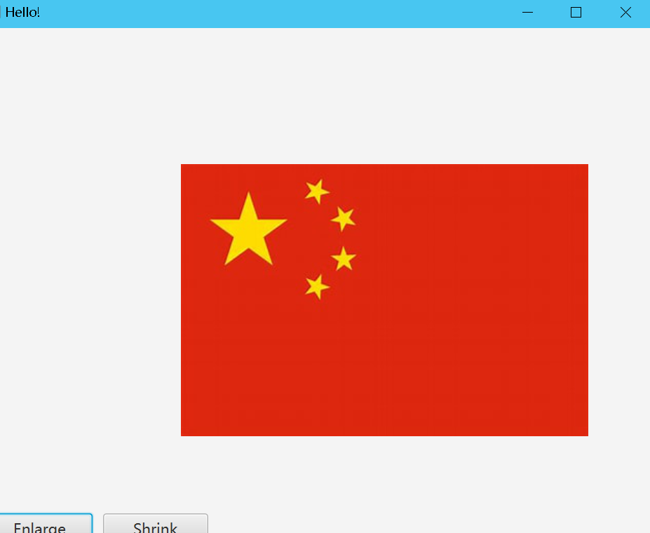

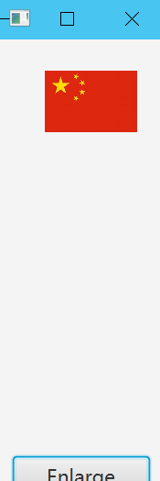

1. Based on quiz8, use Timeline to flash the flag. [Optional] Use PathTransition to move the flag from left to right.
2. 